Electrical Engineering
Computer Systems Engineering
ELE335 – Course Project (Term8 )

Project 2
Integrated Medical Diagnosis Expert System
Course: ELE335 (Artificial Intelligence)

S# | Student Name | Student ID
1 | احمد رجب محمود | 3
2 | اية محمد سيد | 4
3 | شمس هشام السيد | 12
4 | عبد الرحمن ممدوح محمد | 16
5 | عبدالرحمن وحيد عبدالله | 17

Marks

Free Topic Description |  | /40
Problem solving as a search problem | Problem formulation | /40
 | Implementation/Evaluation  /Sample output | /60
 | Project interface & Poster Design | /25
 | Report Style and Formatting | /15
 | Presentation / response to questions | /20
 | Creativity (Bonus) | /10
Expert System in Prolog | Implementation/Evaluation  /Sample output | /60
 | Project interface & Poster Design | /40
Total |  | /300

Table of Contents:-
Introduction
- Overview of the System
- Purpose of the System
Knowledge base
- Diseases
- Symptoms associated with each disease
- Suggested treatments for each disease
Program Logic
- How the system works
- How responses are processed
- Language Selection
Displaying Results with Suggested Treatments
- How results are presented to the user
Conclusion
Member Contributions in Project Tasks

Integrated Medical Diagnosis Expert System
1. Introduction
The Integrated Medical Diagnosis System (IMDS) is a self-help educational system designed to assist people in understanding and diagnosing common medical problems based on symptoms: its primary purpose is to provide users with a general idea of possible diseases based on the symptoms they have reported.
This system is available in English and Arabic language which allows its users to communicate in their own language. The language choice is optional and the diagnostic findings and treatments offered can be communicated in whatever language the user prefers.
Key Features:
- Language support The user is offered the option of translations into English or Arabic – as well as for symptoms and diseases.
- Symptom-based diagnosis The medical system asks people a series of questions about common symptoms and depending on the answers they give, it tells what disease to suspect.
- Treatment suggestions: For each disease that is diagnosed, the system offers general treatment suggestions.
Technologies Used:
The system is implemented in a logic programming language called Prolog. It provides strong features like logical reasoning, backtracking and pattern matching.
We implemented our system using SWI-Prolog and its environment which is more user friendly and supports interactive development.

2. Knowledge base of the system
The knowledge base of the Integrated Medical Diagnosis System contains essential information related to diseases, their associated symptoms, and suggested treatments. This section provides a detailed description of how the data is organized and utilized within the system.
- Diseases KB Section
- The knowledge base includes a collection of common diseases, each represented by a name and a set of associated symptoms. For each disease, the system maintains a list of symptoms, the total number of symptoms, and a mechanism to match these symptoms with the user's responses to generate potential diagnoses.
Examples of diseases included in the system are:
- Flu (الإنفلونزا)
- Common Cold (نزلة برد)
- Allergies (حساسية)
- Strep Throat (التهاب الحلق العقدي)
- Pneumonia (التهاب رئوي)
- Sinusitis (التهاب الجيوب الأنفية)
- Bronchitis (التهاب الشعب الهوائية)
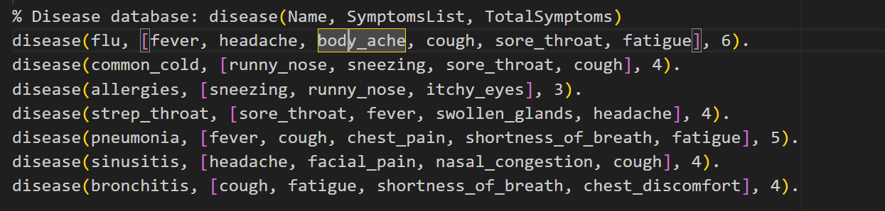

- Symptoms Associated with Each Disease
Each disease in the knowledge base is associated with a set of symptoms. These symptoms are defined as a list and are used by the system to compare with the symptoms entered by the user. The more symptoms the user reports, the higher the probability of a specific disease being diagnosed.
For example:
- Flu has symptoms like fever, headache, body ache, cough, sore throat, and fatigue.

- Suggested Treatments for Each Disease DB Section
- Once a potential disease is diagnosed based on the symptoms, the
system suggests possible treatments. These treatments are general
recommendations and include common remedies or medications that
are typically used for each disease.
For example:
- Flu: Suggested treatments include rest, warm fluids, paracetamol, and oseltamivir for severe cases.
- Common Cold: Treatments include rest, honey with lemon, saline nasal sprays, and acetaminophen for pain relief.
- Strep Throat: Treatments involve antibiotics like Penicillin V, warm saltwater gargles, and ibuprofen for pain.
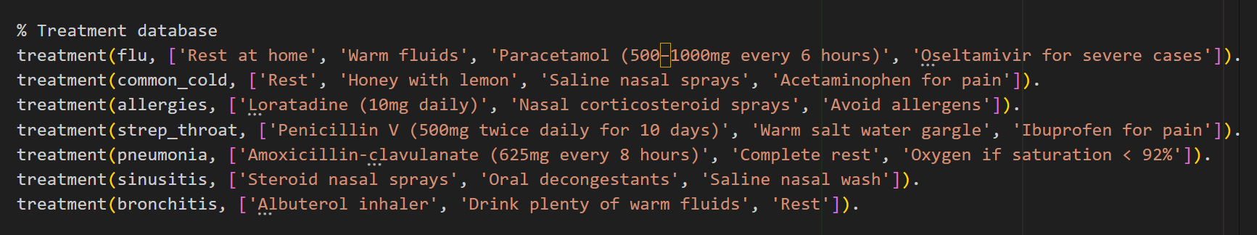

3. Program Logic
- In this section, we will explain the logic and flow of the system. The system is designed to diagnose medical conditions based on symptoms provided by the user. It guides the user through a series of questions about common symptoms, then processes the answers to suggest possible diseases along with their treatments.
1. Program Flow Overview:
The system’s core logic follows these general steps:
- Language Selection: The user selects the preferred language (either English or Arabic) for interaction.
- Legal Disclaimer: Display an important disclaimer about the educational nature of the system.
- Patient Input: The system asks for the patient's name and collects responses about the presence of symptoms.
- Symptom Matching: Based on the user’s answers, the system matches the symptoms to potential diseases.
- Diagnosis Suggestion: The system calculates the possible diseases based on the percentage of symptoms matched and displays the most probable diagnoses along with suggested treatments.
- Repetition: The system loops, allowing users to enter new patient information and diagnose multiple cases.
Important Note:
We add this part at the first of the Project to allow Dynamic predicates in the system, these predicates are crucial for storing user input about symptoms and managing the system's language preferences during interactions.
  - yes/1: Tracks the symptoms that the user confirms as present (answers "yes").
  - no/1: Tracks the symptoms that the user confirms as not present (answers "no").
  - display_language/1: Specifies the language in which the system will interact with the user (either English or Arabic).

- Language Selection (Default Lang is En):
- The system prompts the user to choose a language, either "en" (English) or "ar" (Arabic).
- Based on the choice, the system sets the display_language to either English or Arabic and proceeds with further interaction in that language.
Explaining the predicate choose_language:-
  - The system will ask the user to choose the Language he prefer
  - Then it reads the user's input and store the chosen lang. in variable LangString.
  - Then it changes the user input string into lower case and save it in LangLower
  - Then it changes the string into atom (constant name or key), LangAtom removing the “” from the string to be used in display_language rule
  - The previous languages settings are removed from the system's Knowledge base using retractall(display_language(_)).
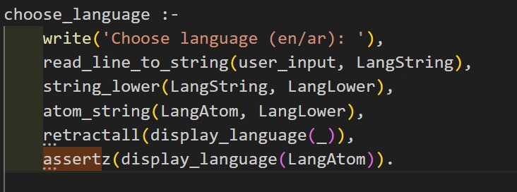
  - The new language preference is then stored in the system's Knowledge base using assertz(display_language(Lang)). This ensures the system uses the selected language for all further interactions.

Explaining the predicate read_line_to_codes:-
- This reads a line of text from the specified Stream (e.g., user_input or any other input stream like a file or keyboard).
- The result is stored as a list of ASCII character codes in the variable Codes.
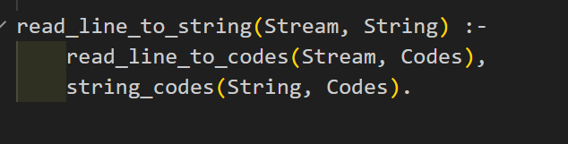
- The string_codes/2 predicate is used to convert the list of character codes (Codes) into a string representation (String).

- Language-Specific Label Fetching for Symptoms and Diseases :

- get_symptom_label/2: This rule retrieves the translation of a symptom based on the selected language.
  - If the language is Arabic (checked with display_language(ar)), it uses the symptom_translation/2 rule to fetch the Arabic translation.
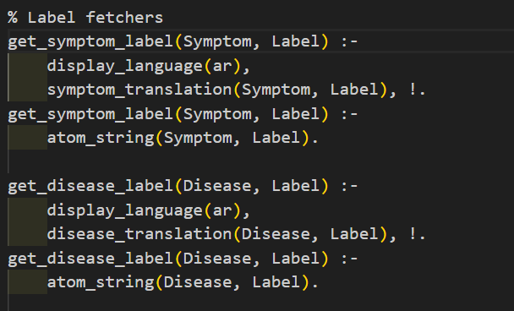
  - If no translation is found or if the language is English, it returns the symptom name as it is, in English.

- get_disease_label/2: Similarly to get_symptom_label/2, this rule retrieves the translation of a disease based on the selected language.
- Use of ! (Cut) Operator:
  - In both the get_symptom_label/2 and get_disease_label/2 rules, the ! operator ensures that once a translation is found (i.e., when the language is Arabic), Prolog will not continue trying to find other possible translations or paths. This helps improve efficiency and prevents unnecessary computations.
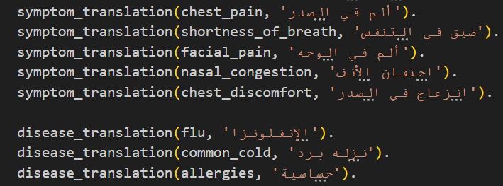
• Legal Disclaimer:
The legal disclaimer is an important part of the program to ensure that users are aware of the system's limitations. It emphasizes that the system is for educational purposes only and should not be relied upon for medical decisions. Users are strongly advised to consult a professional healthcare provider for a proper diagnosis and treatment plan. The disclaimer is displayed at the beginning of the program based on the selected language, ensuring that users can clearly understand the limitations regardless of the language they choose.
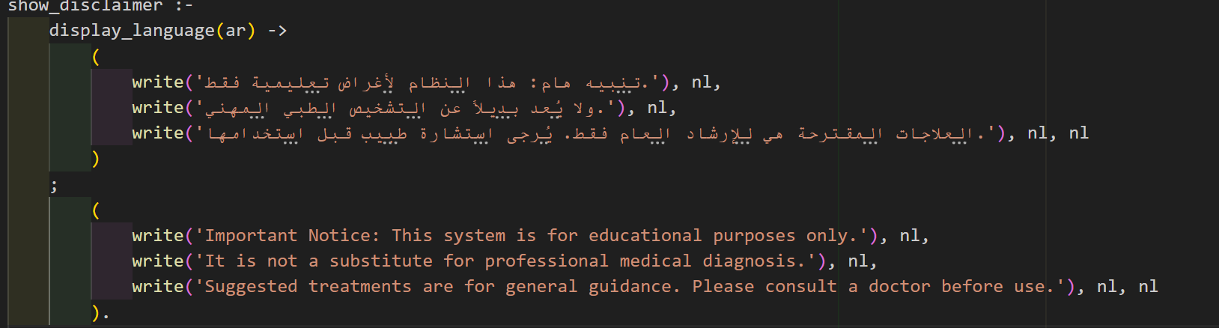
• Patient Input and Start Prompting:
The ask/2 rule is responsible for interacting with the patient to gather input about their symptoms.
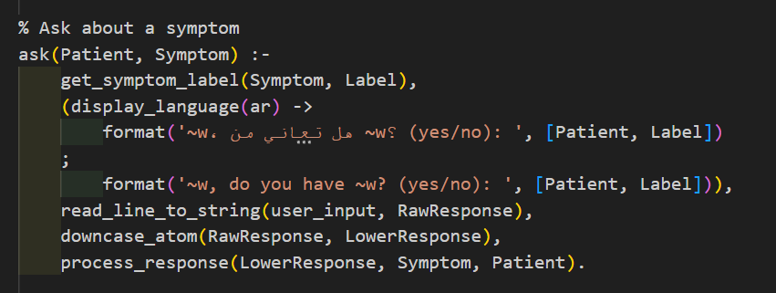
It works as follows:
- Symptom Translation: The rule first retrieves the label for the symptom using the get_symptom_label/2 rule, which checks the language preference. If the language is Arabic (display_language(ar)), it fetches the Arabic translation of the symptom. Otherwise, it uses the English name for the symptom.
- Asking the Question: Based on the language selected, the system asks the patient whether they experience the symptom.
- Reading Patient Input: The patient’s response is read as a string using the read_line_to_string/2 predicate. The raw response is stored in RawResponse.
- Normalizing the Response: The input is then converted to lowercase atom using the downcase_atom/2 predicate to ensure consistency in response handling. This ensures that answers like "YES," "Yes," or "yes" are treated the same.
- Processing the Response: Finally, the process_response/3 rule is called, passing the normalized response (LowerResponse), the symptom name (Symptom), and the patient's name (Patient). This rule processes the response by either adding the symptom to the list of matched symptoms or handling the response in another appropriate way.
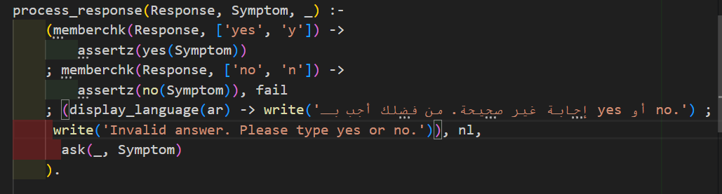

Displaying Results with Suggested Treatments
  - Processing Patient Responses
The process_response/3 rule is responsible for handling the patient's input and determining whether a symptom is present based on the patient's response. It works as follows:
- Yes Response: If the patient's response is "yes" or "y," the symptom is recorded as confirmed by adding it to the yes list using assertz(yes(Symptom)). This indicates that the patient has the symptom.
- No Response: If the response is "no" or "n," the symptom is recorded as not present by adding it to the no list with assertz(no(Symptom)). The rule then uses fail to stop the current predicate and move on to the next part of the process.
- Invalid Response: If the response is neither "yes" nor "no," the system displays an error message prompting the user to enter a valid answer. Depending on the language selected, the message is either in Arabic or English, asking the patient to provide a valid response. The system will then re-ask the patient about the same symptom.
  - Verify Symptom
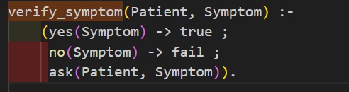

The verify_symptom/2 rule checks if a patient has already confirmed a symptom as "yes" or "no." If the answer is already recorded, it moves forward or stops based on the response. If not, it asks the patient for confirmation.

- Yes: If the symptom is confirmed as "yes," it moves forward.
- No: If the symptom is confirmed as "no," it prevents further questions.
- Unknown: If the answer is not recorded, it asks the patient again.
This ensures the system avoids asking the same question repeatedly.
• Symptom Matching and Diagnosis Suggestion:
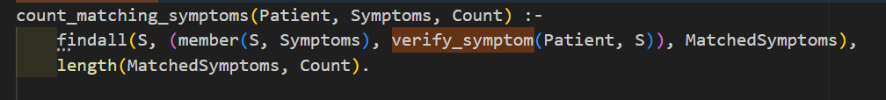
This rule counts how many symptoms match based on the patient's responses.
1.findall/3:
  - The findall(S, (member(S, Symptoms), verify_symptom(Patient, S)), MatchedSymptoms) part collects all symptoms (S) from the list Symptoms where the patient’s response for that symptom is either "yes" or "no." and then save them in MatchedSymptoms List.
  - verify_symptom/2 ensures that each symptom is checked if the patient has confirmed it.
- length/2:
  - length(MatchedSymptoms, Count) calculates how many symptoms the patient has matched and stores the number in Count that we will use in calculating the percentage of the disease infection.
• Print Result with treatments
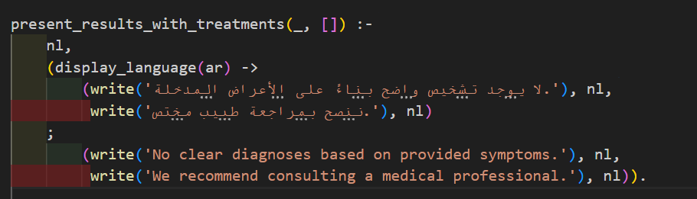
In the case where no diagnosis can be made based on the symptoms provided by the patient, the system will inform the user that there is no clear diagnosis available. The message will encourage the patient to consult a medical professional. Depending on the selected language, the system will display this message either in Arabic or English.

- Important Note :
1.(_) indicates that the patient's information is not relevant for this rule, as we're dealing with the case where no clear diagnosis is found.
2.[] means the list of filtered diseases is empty, meaning no diseases were identified based on the entered symptoms
3.1 Print Result with treatments
The present_results_with_treatments/2 rule displays potential diseases based on the symptoms entered by the patient. It provides a formatted message in the selected language (Arabic or English). The rule sorts the diseases, prints them along with possible treatments, and includes a disclaimer that the results are for guidance only and the patient should consult a doctor before starting any treatment.
- Language Handling: Displays messages in either Arabic or English, depending on the selected language.
- Disease Sorting and Display: Sorts the diseases and presents them along with corresponding treatments.
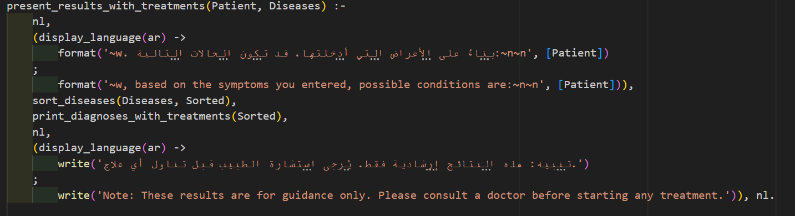
- Disclaimer: A final message informs the patient to consult a doctor for proper diagnosis and treatment.

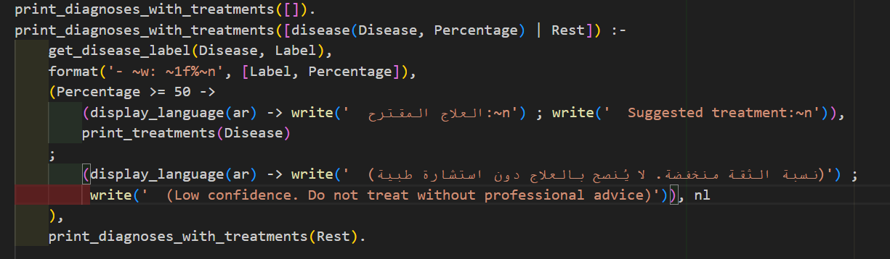
3.2 Print Result with treatments

This function is responsible for printing the diagnoses and the suggested treatments based on the patient's symptoms. It processes the list of possible diseases, displaying each disease's name and its associated confidence percentage. Depending on the confidence level, it either suggests treatments or advises caution.
- Base Case: The function terminates when the list of diseases is empty, meaning there are no more diagnoses to display.
- Recursive Case: For each disease in the list, the function:
  - Prints the disease's name along with the calculated confidence percentage.
  - If the confidence percentage is 50% or higher, the function proceeds to suggest treatments for the disease.
  - If the confidence is below 50%, the function warns that the diagnosis is uncertain, and the patient should consult a medical professional before taking any action.
This process is repeated for each disease in the list using recursion, ensuring all diseases are evaluated and presented properly.
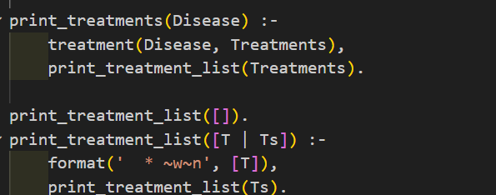
3.3 Print Result with treatments
print_treatments/1: This predicate is responsible for retrieving the suggested treatments for a specific disease and printing them one by one. It works by calling another predicate, print_treatment_list/1, which handles the actual formatting and printing of each treatment.
- It retrieves the treatments associated with the given disease by using the treatment(Disease, Treatments) fact.
- Then, it calls print_treatment_list/1 to format and display each treatment from the list of treatments.
print_treatment_list/1: This predicate handles the printing of the treatments. It uses recursion to process the list of treatments and display each one in a formatted manner.
- Base Case: When the list of treatments is empty ([]), the recursion stops.
- Recursive Case: For each treatment T in the list, it prints the treatment with the format ' * Treatment'. Then it recursively calls itself to print the rest of the treatments.
3.4 Print Result with treatments
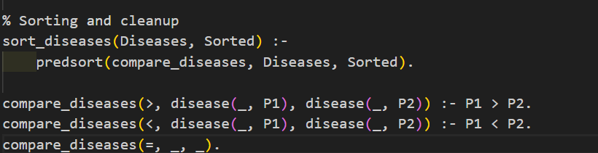

- sort_diseases/2: This predicate takes a list of diseases Diseases and returns a sorted list Sorted.
- predsort/3: This predicate uses a comparison predicate (like compare_diseases in this case) to sort the elements of the list. It calls the comparison predicate to compare the elements and sort them accordingly.
- The compare_diseases predicate is the one that defines how the diseases will be compared and sorted based on the percentage (Percentage).
- First Rule (compare_diseases(>, disease(_, P1), disease(_, P2))):
  - If P1 (the first percentage) is greater than P2 (the second percentage), it returns > (meaning the first disease is greater than the second disease, then the second disease should come before the first disease (ascendingly) ).
- Second Rule (compare_diseases(<, disease(_, P1), disease(_, P2))):
  - If P2 (the second percentage) is greater than P1 (the first percentage), it returns < (meaning the second disease should come after the first disease in the sorted order).

- Third Rule (compare_diseases(=, _, _)):
  - If both percentages are equal (P1 = P2), it returns = (indicating no difference in the order between the two diseases).
- The Main entry of the system and Repetition
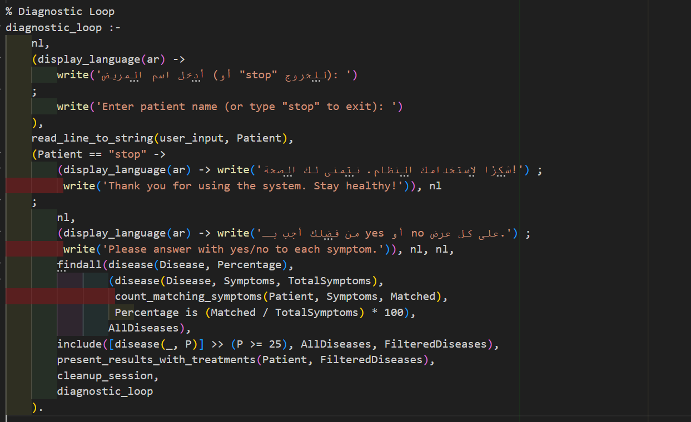
Diagnostic Loop Explanation
The diagnostic_loop/0 predicate is the main interactive loop of the expert system. It guides the diagnosis process step by step as follows:
- Patient Input:
  - The system prompts the user to enter the patient's name (or type "stop" to exit the loop).
  - This allows repeated diagnoses for multiple patients within the same session.
- Instruction Display:
  - After receiving the patient name, the system displays instructions asking the user to answer each symptom with "yes" or "no".
- Disease Scanning:
- findall/3 collects a list of diseases, each represented as disease(Name, MatchPercentage) as a template for the output list AllDiseases.
- For each disease:
  - The system calls count_matching_symptoms/3, which:
  - Asks the user about each symptom in the disease’s symptom list,
  - Counts how many of the symptoms were confirmed ("yes"),
  - Returns the count as Matched.

- Filtering:
  - After generating AllDiseases, the system filters out any disease with a match percentage below 25%

- Cleanup:
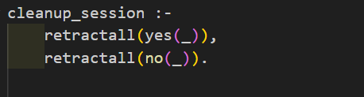
- The system clears any temporary data related to the current patient using cleanup_session/0 to prepare for the next run.

Results
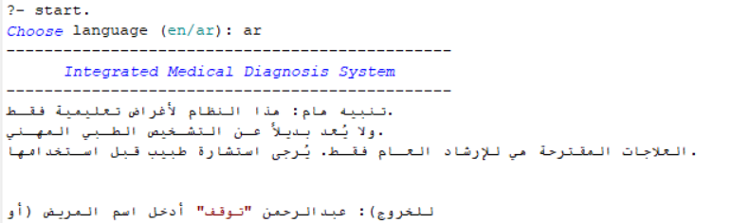

Choosing Arabic language as system language
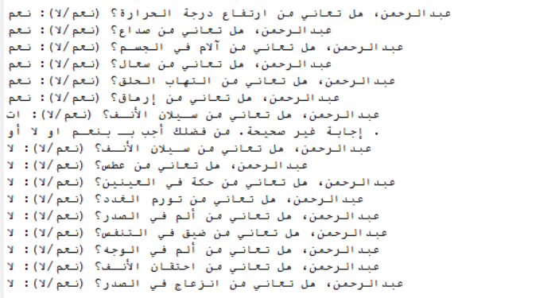

Showing and answering questions about symptoms
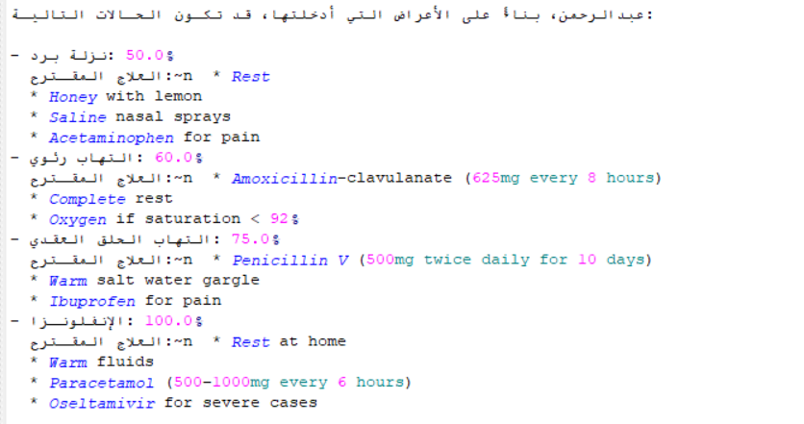

Diagnosis and showing the recommended treatment
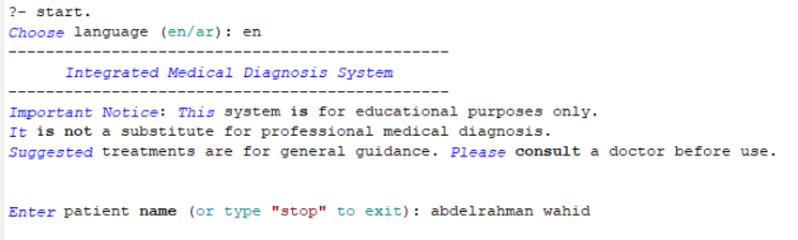

Choosing English language as system language
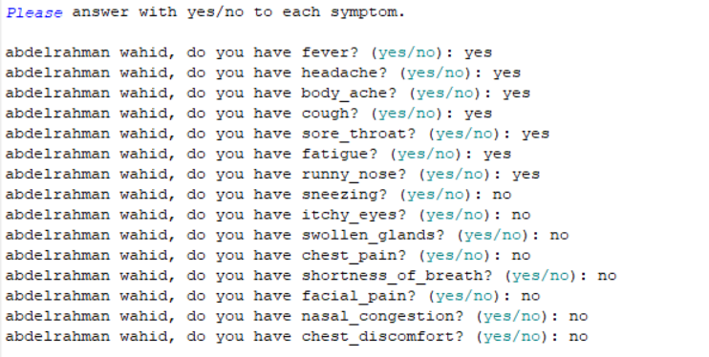

Showing and answering questions about symptoms
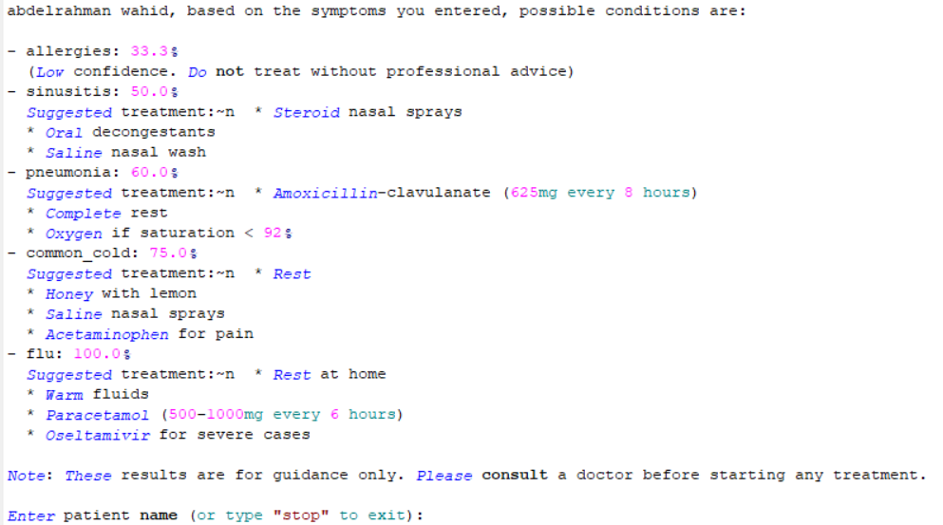

Diagnosis and showing the recommended treatment

Conclusion
In this expert system, we designed an interactive diagnostic loop that allows users to repeatedly check for diseases based on symptoms. The system collects patient responses dynamically, calculates match percentages for each disease, and filters out irrelevant results to present meaningful diagnoses along with their treatments. This loop ensures continuous usability by allowing multiple patients to be diagnosed in one session, with clear prompts and real-time feedback. The design focuses on simplicity, modularity, and clarity, making the system both user-friendly and maintainable for future extensions or improvements.
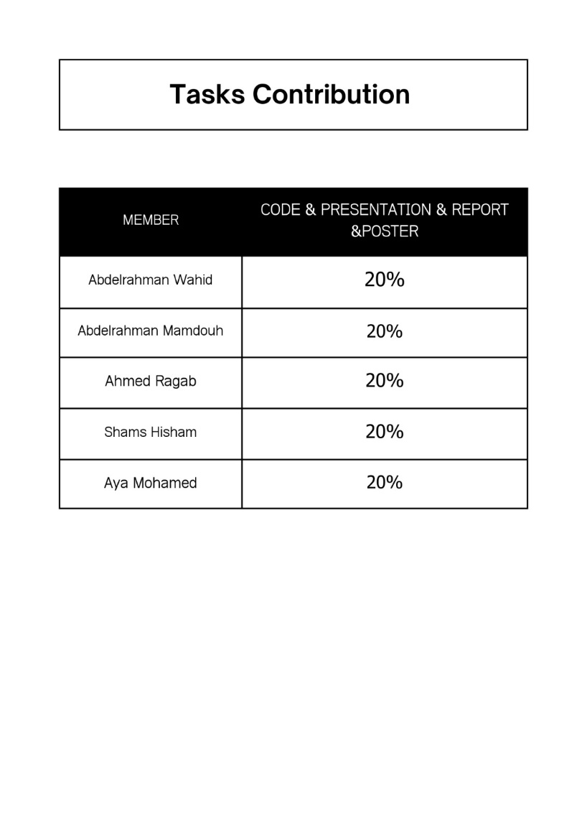
Tasks Contributions: - all team members contribute the same effort in code, presentation, report and poster of this project as shown below

